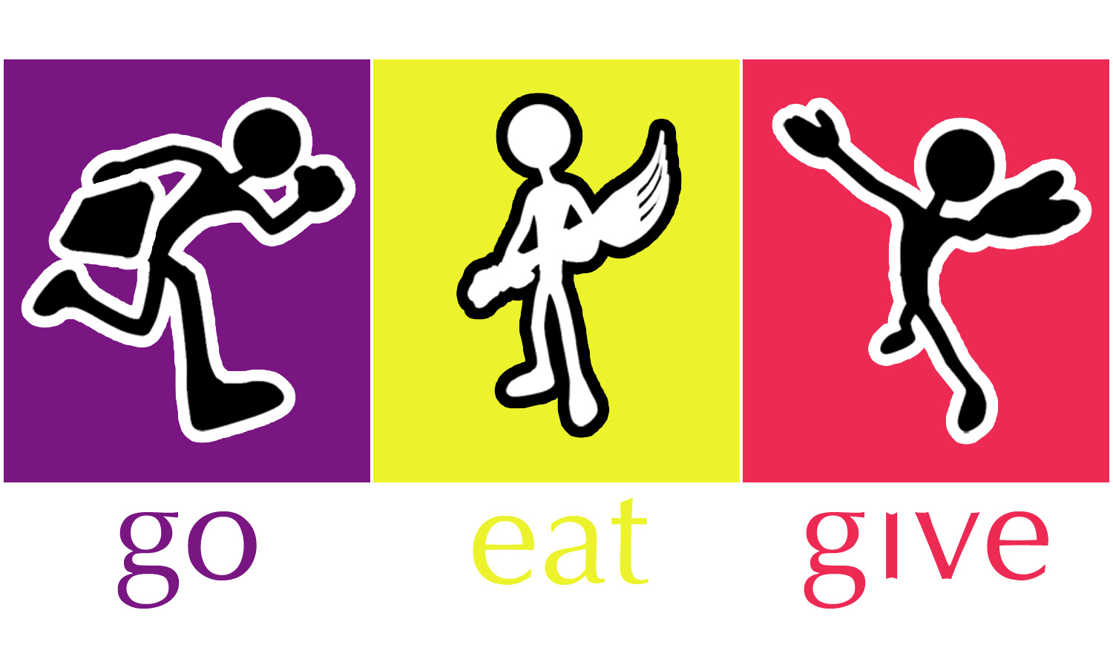
Join Go Eat Give as a Contributing
Travel Writer or Photographer

Go Eat Give’s Mission

Go Eat Give is a 501(3)(c) registered non-profit organization with a mission to raise awareness of different cultures through food, travel and community service. We showcase the authentic cuisine and culture of counties through volunteer vacation programs, Destination Dinners, speaker series, cooking classes and our award winning blog. We believe that by learning about the way people live, what they eat at home and believe in, you get to understand them better. By creating positive enriching interactions, we hope to end stereotypes, bigotry and violence.

Who Reads Go Eat Give Blog?

The blog was started in 2011 as a movement to educate people about different cultures, and it birthed the nonprofit. Go Eat Give readers are curious, engaged, active citizens of the world—college-educated men and women who have good jobs and high incomes. They are looking for experiences and connections that touch them personally. They are also looking for authenticity in people, places, and things. They seek these values in all facets of their lives, but they find a special thrill in doing so through travel.

Why Contribute to Go Eat Give?

- Build your portfolio
- Share your work with our readers across 120 countries
- Allow us to promote you as a contributing writer/ photographer at a global movement for change
- Inspire others to get out there!
- Go Eat Give was named "one of the 5 most influential blogs on culture in the world" by the Foundation of Florence in 2012

Travel Writer Program

Before you get started, search goetagive.com for past articles so you don’t pitch something we’ve already covered. Then read these guidelines for further instructions. Happy pitching!

Step 1 – Find a category you’d like to write a piece for.

GO
Destination Details USA – Cities, villages, & off the beaten path towns that are overlooked by tourists. If you are very familiar with a particular city (could even be your hometown), we’re looking for posts that will give an insider’s view on where to stay, what to do and where to dine.

Destination Details International–If you visited another country, & can write an insider’s view on where to stay, what to do and where to dine. Perhaps some unique activities & hidden gems.

Unique Hotels – Have you always wanted to be a hotel critic? Here is your chance! Tell us about your favorite property and what makes it worth writing out. Pay special attention to hotels on trees, carved from ice in the rainforest, boutique hotels, eco lodge, sustainable properties, castles & more.

EAT
The Dish - Focuses on a dish that’s specific to a city or region, providing insight on the dish’s history and significance in the local culture. The piece also provides information on where to sample the dish within its home country as well as a step-by-step recipe.
Restaurants – A unique restaurant in any part of the world that is serving more than phenomenal food. We are looking for new concepts in coffee shops, bars, floating restaurant, barter meals, etc.
Beverage – Found an out of the world bar that has a wine collection like no other? Discovered a mixologist who is worth a story?

GIVE

Reader Perspective – We seek first-hand perspective pieces from readers who have traveled, studied, worked or volunteered abroad. Some of our fan favorites have been pieces about a first solo trip abroad or the adventures of getting lost in a country where you don’t speak the language.

Profile of people making a difference – Came across someone who started a community project to end hunger at his village; to start an organic indigo farm after the revolution; or a travel company that educates locals about conservation and employs them in hospitality industry.

OTHER
Favorite Things – Do you keep track of the most useful, cutest, coolest products that make life and travel easier? Help our readers find the best products by putting together articles of recommendations. Books, Luggage, Kitchen Gadgets & others make good stories & can get you free stuff. (Always ask for an extra piece to give away to your readers).

Events and Festivals – Going to the Burning Man, Russian Olympics, The Pushkar Mela? We want to hear your experiences. An informative recap of the Food and Wine Festival in your city will be good too.

Step 2 - Email us your story pitches
Please include a little background on yourself, what topic(s) you have in mind, why you’re the best person to write them and a link to your blog, website or writing samples (if applicable). Email to editor@goetagive.org. Pitches will be read by editors on the Go Eat Give team.
Step 3 – Get to work
Once your pitch is approved, get to work! We target 500-700 words per post. Please include a few photos as well to include with your post (It would be great if you can be the primary subject in at least one of them). We also have a very simple Writer’s Agreement that all guest writers must acknowledge.
Step 4 – Queue for publishing
Go Eat Give editors will format your post and get it into the queue for publishing. If you have a website or blog, we can include a link to that in your bio.
Step 5 – Published!
When your post is live, we’ll email you the URL so you can start sharing. We encourage you to share the link with friends and family and to post it on Facebook and Twitter. We’ll do the same!

Travel Photographer Program
A picture is worth a thousand words and there is no better way to inspire a traveler than with a breathtaking snap of a destination. To be considered for Photo of the Week, follow these steps:
Step 1 – Send us your photos.
Select your favorite five photos for consideration or a link to a web album (preferred) to editor@goeatgive.org. Make sure to write titles and tell a story through your photos. We’ll take a look and contact you if we’d like to include one of your images.
Step 2 – Send high-resolution picture.
After an image has been selected, we will request a JPEG file of the photo to be emailed to us.
Step 3 – Queue for publishing.
We will email you back with an approximate publication date. At current time, we feature Photo of the Week on Fridays.
Step 4 – Published!
When your photo gets published, we will send you a link to the post. We encourage you to share the link with friends and family and to post it on Facebook and Twitter. We’ll do the same!
We look forward to your contributions!

